Introduction
- The easiest way to ensure interpretability in machine learning is by using models that are interpretable by design.
- Simple algorithms, like a single decision tree, are often sufficient for less complex problems—following Occam’s razor, where the simplest solution is usually best.
- Models covered in this video—Logistic Regression, Decision Trees, and Microsoft’s Explainable Boosting Machine (EBM)—are known as "glass box" models because their inner workings are directly observable and transparent.

Dataset for this series
- A health dataset sourced from Kaggle is used throughout the series to predict whether a person is likely to suffer a stroke (a binary classification problem).
- Features in the dataset include age, gender, work type, residence type, hypertension, heart disease, marital status, and Body Mass Index (BMI).
- The dataset is imbalanced: out of 5,000 instances, only ~300 patients had a stroke.
- Code implementation in VS Code uses cell magic and a custom DataLoader class to read the data, preprocess categorical features using one-hot encoding, impute missing BMI values with zero, drop unnecessary columns (id), and perform oversampling on the minority class for training.

Logistic Regression
- Extends linear regression to binary classification by passing a weighted linear sum of inputs through the sigmoid function:
Y = $1/(1+e^{-z})$

Interpretability:
  - For continuous features, increasing feature x_{j} by 1 unit multiplies the odds by e^{βj}
  - Predictions are calculated transparently, allowing straightforward assessment of each input feature’s contribution to the final output.

Model Implementation & Performance:
  - Implemented via Microsoft's interpret.glassbox module.
  - Achieved an accuracy of 73% and an F1 score of 0.51 on the stroke test dataset.
  - explain_local plots display individual feature contributions (e.g., age positively driving risk, while being married or never having smoked reduces risk).
  - explain_global visualizes overall global feature importance coefficients.

Decision Trees
- Non-linear models that split data based on decision rules at each node, ending at prediction leaf nodes (e.g., stroke vs. no stroke).
- Splits are determined by evaluating information gain through entropy (e.g., ID3 algorithm).
Interpretability:
  - Can be interpreted as a set of human-friendly if-else decision rules.
  - Local explanations display the exact decision path (highlighted in red) taken by an individual instance through the tree structure.
  - Interpretability decreases as tree depth grows large; shallow trees remain fully transparent.

Model Implementation & Performance:
  - Evaluated using ClassificationTree from interpret.glassbox.
  - Achieved an accuracy of 73% and an F1 score of 0.52.

Explainable Boosting Machine
- Developed by Microsoft Research to eliminate the trade-off between high accuracy and interpretability.
- Constructs thousands of small decision trees (e.g., 10,000 iterations) where each individual tree is restricted to using only one specific feature (or pair of features for interaction terms).

Interpretability & Visualizations:
  - Aggregates tree outputs into feature dependence plots that directly show the feature's marginal contribution to the output log-odds.
  - Local explanations highlight specific numerical feature values (e.g., age of 8 reducing risk vs. older age increasing risk) pushing the prediction toward stroke or no stroke.
  - Global feature plots rank overall feature importance (age, BMI, and glucose levels emerge as top factors).

Model Performance:
  - Outperformed linear and decision tree baselines, achieving an accuracy of 87% and an F1 score of 0.55 while retaining total interpretability.

The Power of Feature Engineering

Why you should probably just use logistic regression to model non-linear decision boundaries

What is Feature Engineering
You are doing feature engineering any time you create features from raw data or add functions of your existing features to your dataset. This is usually done using domain knowledge of a particular field. For example, let say we want to predict the amount of time it takes a person to recover from an operation (Y). From previous operations, we have captured the patient’s recovery time, height and weight. From this data, we can also calculate the BMI = height/weight² of each patient. By calculating and including BMI in the dataset, we are doing feature engineering.

Why we do Feature Engineering
Feature engineering is powerful as it allows us to reformulate non-linear problems as linear problems. To show this, suppose recovery time has the following relationship with height and weight:
Y = β₀ + β₁(height) + β₂(weight) + β₃(height/weight²) + noise
Looking at the 3rd term, we can see that Y does not have a linear relationship with height and weight. This means that we would probably not expect a linear model, such as linear regression, to do a good job at estimating the β coefficients. You could try using a non-linear model, such as a DNN, or we can help our model by doing some feature engineering. If we decide to include BMI as a feature, the relationship becomes:
Y = β₀ + β₁(height) + β₂(weight) + β₃(BMI) + noise
Y can now be modelled as a linear relationship of our 3 variables. As a result, we would expect linear regression to do a much better job of estimating the coefficients. Later on, we will see that the same idea applies to classification problems.

Dataset
Let’s dive into a practical example. To keep things as clear as possible, an artificially generated dataset will be used. To keep the example from being incredibly dull, we’ll create a narrative around it. So, let’s say that your HR department has asked you to create a model that predicts whether an employee will be promoted or not. The model should consider an employee’s age and performance score.
We create the features for 2000 hypothetical employees in the code below. The employees can have an age between 18 and 60. The performance score can be between -10 and 10 (10 being the highest). Both features are shuffled so that they are not correlated. We then use the following function of age (a) and performance (p) to generate the target variable:
γ(a,p) = 100(a)+ 200(p)+ 500(a/p)- 10000 + 500(noise)
When γ(a,p)≥ 0 then an employee is promoted when γ(a,p) < 0 the employee is not promoted. We can see that the term a/p is included in the function above. This means that the decision boundary will not be a linear function of age and performance. Random noise is also included so that the data is not perfectly separable. In other words, it shouldn’t be possible for a model to be 100% accurate.
Don’t worry if the steps above are a bit confusing. We can make things clearer by visualising the dataset with the code below. Here we create a scatter plot of the data and the result can be seen in Figure 1. With only two features, it is easy to see exactly what is going on. On the y-axis, we have the employee’s performance score and on the x-axis, we have the employee’s age. The points for promoted employees are given a red colour and those not promoted are given a blue colour. In the end, 459 of the 2000 employees (23%) received promotions. This ratio will change slightly for different random samples.

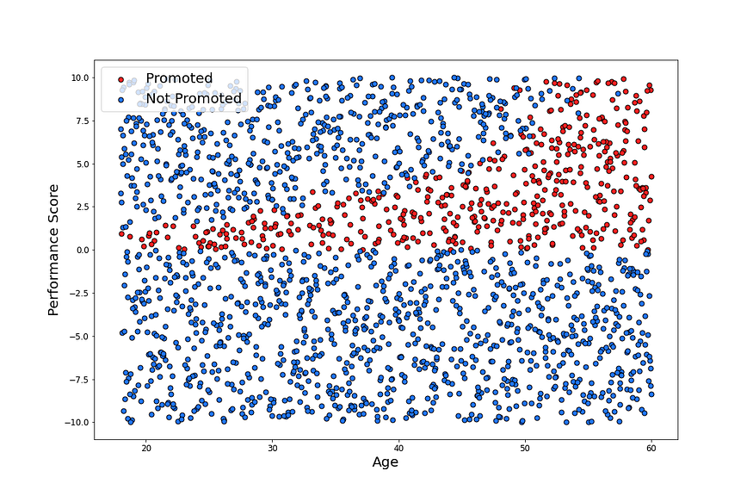
Figure 1: Scatter Plot of Promotion Data
Although this data is generated, we can still come up with a realistic explanation for the plot. In Figure 1, we can see 3 distinct groups of employees. The first is the group with a performance score below 0. Due to poor performance, most of these employees did not get promoted and we could also expect a few of them to have been fired. We can expect employees with a score above 0 to either get a promotion or take an offer somewhere else. Employees with particularly high scores tend to leave. This is probably because they are in high demand and have received better offers elsewhere. However, as an employer gets older, they need a higher performance score to leave. This could be because older employees are more comfortable in their current positions.
Whatever the narrative, it is clear that the decision boundary is not linear. In other words, it is not possible to draw a straight line that separates the promoted an not promoted groups well. As a result, we would not expect a linear model to do a very good job. Let’s demonstrate this by trying to fit a logistic regression model using just the two features — age and performance.

Logistic Regression
In the code below, we split our 2000 employees into a training set (70%) and a test set (30%). We use the training set to train a logistic regression model. Then, using this model, we make predictions on the test set. The accuracy on the test set was 82%. This may not seem too bad but we should consider that just under 23% of the employees received a promotion. So, if we just guessed that none of the employees would get a promotion we should expect an accuracy of around 77%.
We can get a better understanding of what the model is doing by visualising its decision boundary using the code below. Here we generate a million points within the sample space. We then use the logistic regression model to make predictions on all those points. Like with the scatter plot in Figure 1, we can plot each of these points. The colour of each point is determined by the model’s prediction — pink if the model predicts a promotion and light blue otherwise. This gives us a good approximation of the decision boundary which can be seen in Figure 2. We can then plot the actual dataset on top of these points.
Looking at the decision boundary, we can see the model is doing a terrible job. Roughly half the employees it predicts as having promotions are not promoted. Then for most of the employees that got promotions, it predicts that they did not get promotions. Notice that the decision boundary is a straight line. This emphasises that logistic regression is a linear classifier. In other words, the model can only construct a decision boundary that is a linear function of the features you give it. At this point, we may be tempted to try a different model but let’s see if we can improve the performance using feature engineering.
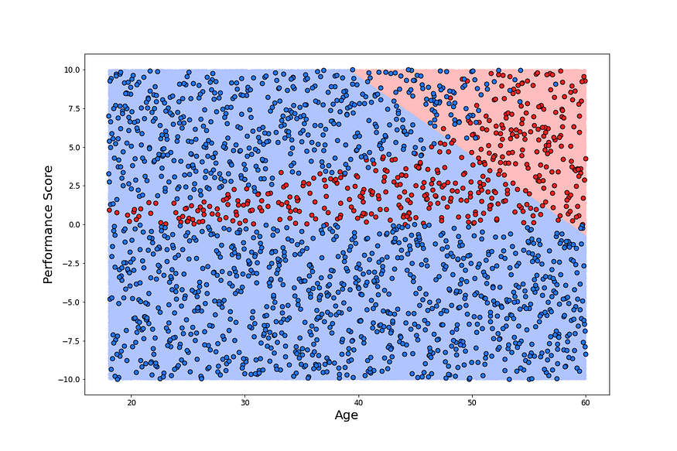
Figure 2: Decision Boundry of Logistic Regression Model

Logistic Regression with Feature Engineering
Firstly, shown in the code below, we add the additional feature (i.e. the ratio of age to performance). From then, we follow the same process as the previous model. The train test split is the same as we are using the same value for the “random_state”. In the end, this model achieved an accuracy of 98% which is a significant improvement.
The model still only needs the employee’s age and performance in order to make predictions. This is because the additional feature is a function of age and performance. This allows us to visualise the decision boundary the same way as before. That is by using the model’s prediction at each age-performance point in the sample space. We can see that, in Figure 3, by adding the additional feature, the logistic regression model is able to model a non-linear decision boundary. To be technically correct, this is a non-linear function of age and performance but it is still a linear function of all 3 features.
Press enter or click to view image in full size
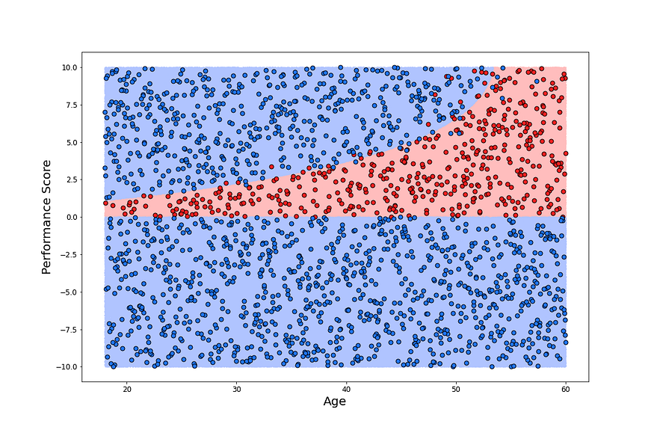
Figure 3: Decision Boundry of Logistic Regression Model with Feature Engineering
An additional benefit of using logistic regression is that the model is interpretable. This means that the model can be explained in human terms[4]. In other words, we can look directly at the model coefficients to understand how it works. We can see the coefficients for our model features, along with their p-values in Table 1. We won’t go into to much detail, but the coefficients allow you to interpret changes in the feature in terms of changes in the odds of getting a promotion [5]. If a feature has a positive coefficient, then an increase in that features value results in an increase in the odds of getting a promotion.
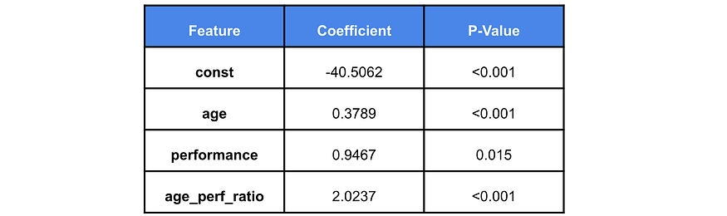
Table 1: Logistic Regression Model Summary
Looking at Table 1, we see that as age increases the likelihood of getting a promotion increases. For performance, on the other hand, the relationship is not as clear. An increase in performance would also decrease the age/performance ratio. This means that the effect, on the odds, of an increase in performance depends on the employee’s age. This makes a lot of intuitive sense as it is in line with what we have seen in the scatter plots. In this case, it is probably not necessary to use the coefficients to interpret the model in this way. It was enough to just visualise the decision boundary but, as we increase the number of features, it becomes more difficult to do this. When this is the case, the model coefficients are a great tool in understanding how the model works.
Similarly, the p-values can aid our understanding of the model. As coefficients are statistical estimates, they have some uncertainty around them. Low p-values allow us to be certain that our coefficients are different from 0. In other words, we can be certain that a coefficient is either positive or negative. This is important as, if we are not certain of a coefficient’s sign, it is difficult to interpret a change in the features in terms of a change in the odds. Looking at Table 1, we see that all the coefficients are statistically significant. This is not surprising as we generated the data using a function of the features.
Overall, as we generated the data, the analysis above was quite straight forward. Because we know what function was used to generate the data, it was obvious that the additional feature would improve the model’s accuracy. In reality, it would not be so simple. If you didn’t have a good understanding of the data you’d probably have to talk to someone in the HR department. They may be able to inform you of any trends they’ve seen in the past. Otherwise, by exploring that data using various plots and summary statistics you can get an idea of what features may be significant. But, suppose we didn’t want to do all this hard work.

